Web Application Acceleration with ORM Stack

Contents

1. Introduction 3
2. Workflow diagram to deploy the stack 3
3. Create stack for the web application acceleration 4
4. Plan the Job 7
5. Apply the Job 8
6. Verify in the Console 9
7. Destroy the stack 10

Introduction

Web Application Acceleration is a service that can speed up traffic on layer 7 HTTP load balancers by applying a combination of caching and compression. This combination of speed enhancements is configured as a web application acceleration policy. The policy includes the caching or caching and compression. After the web application acceleration policy is created, you assign the policy to a load balancer as an acceleration resource of the policy.

Workflow diagram to deploy the stack
Below diagram shows how the Terraform Artifact are applied in the OCI. While creating a ORM stack, using terraform deliverables Init, Plan and Apply is the flow to provision the resource in the OCI. We can have the deliverables in any of below.
- GitLab/GitHub Repo
- Bitbucket
- Can be in folder/.zip in the local disk
- Object Storage Bucket
- Can be in compartment
- Oracle provided Template


Create stack for the web application acceleration

Go to OCI Console Developer Services Resource Manager Stacks select the compartment Create Stack

My Configuration Folder Browse Select the “web application acceleration” folder that contains the terraform Upload

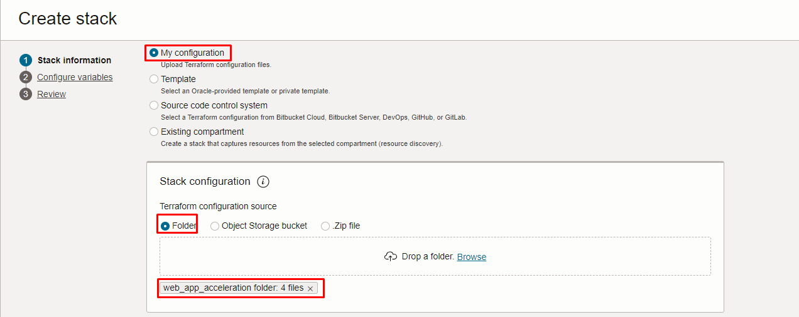

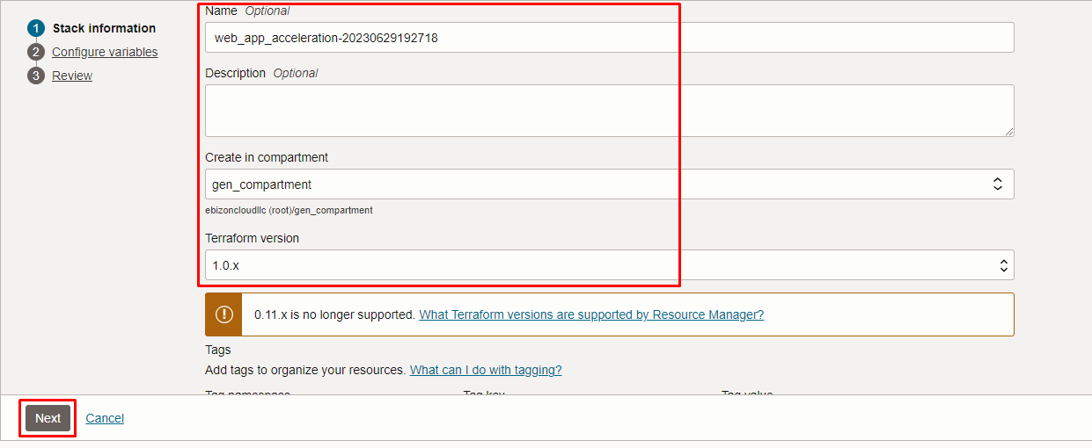
Click “NEXT”

Select the parameters as per the below screen,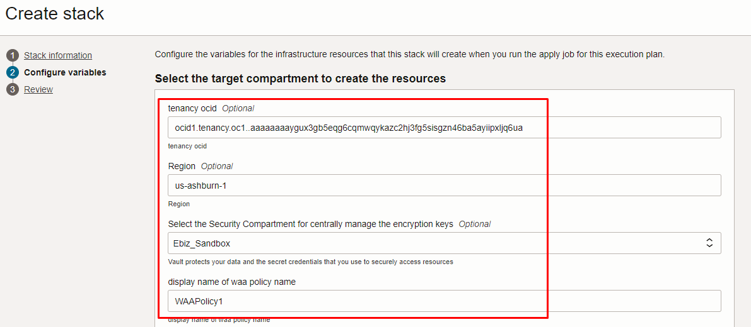

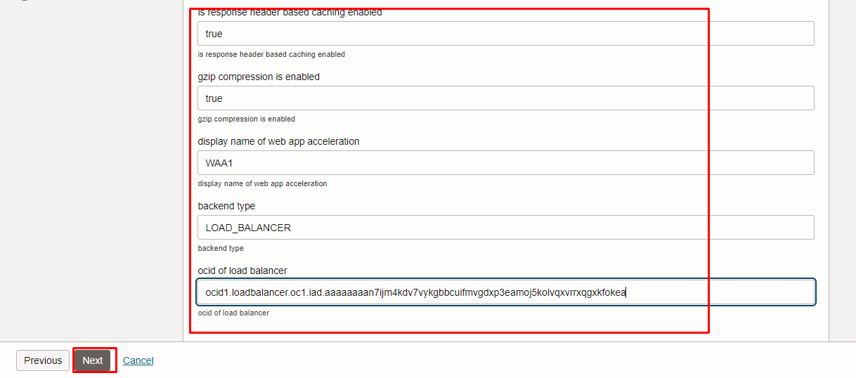
Click “NEXT” Click “CREATE”
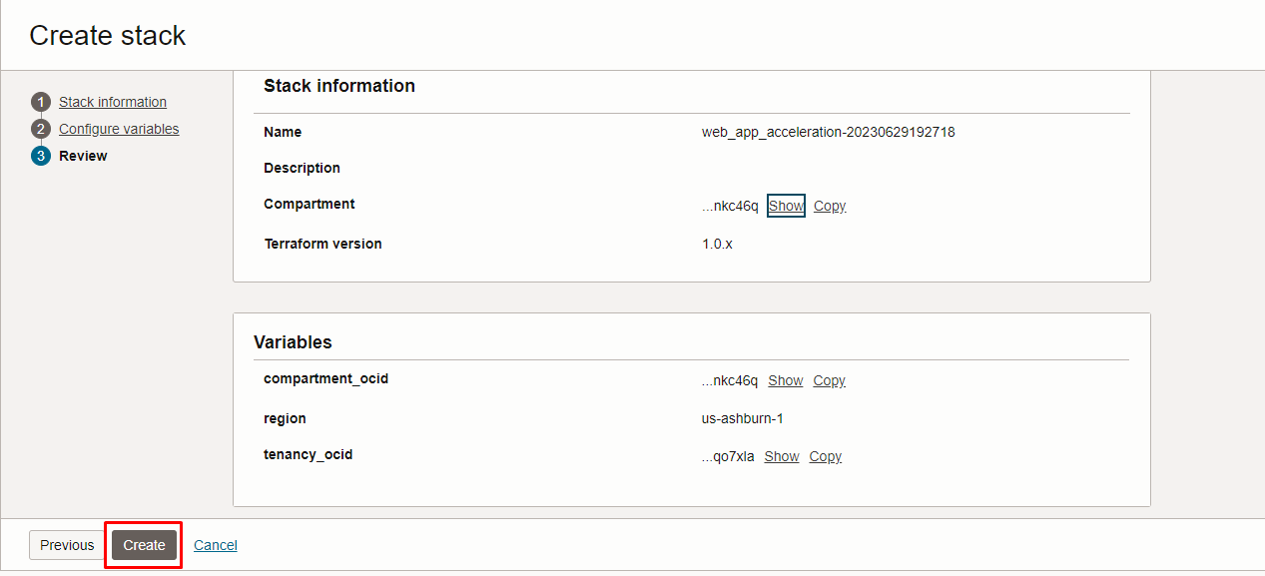

Plan the Job
Click the “Plan”

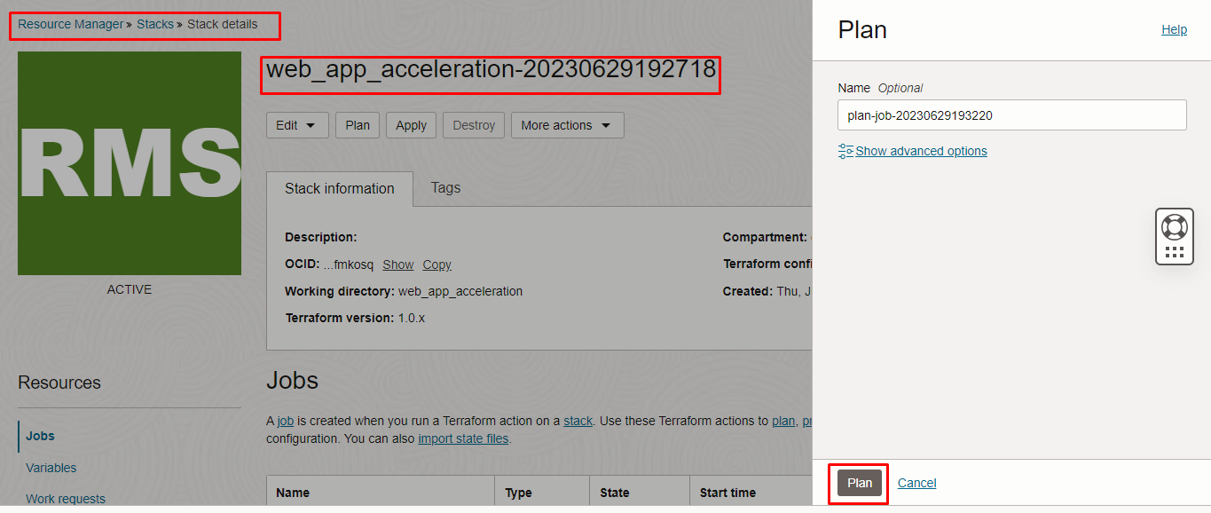

Verify the Plan is successful.

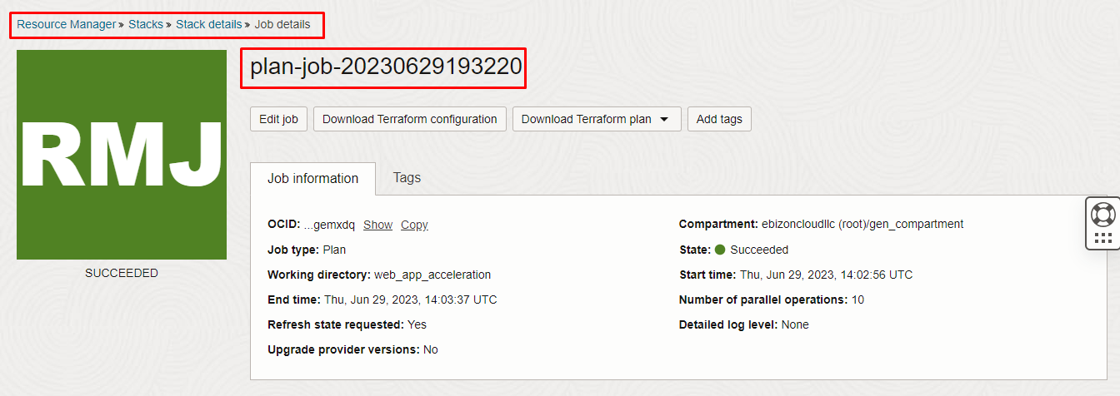
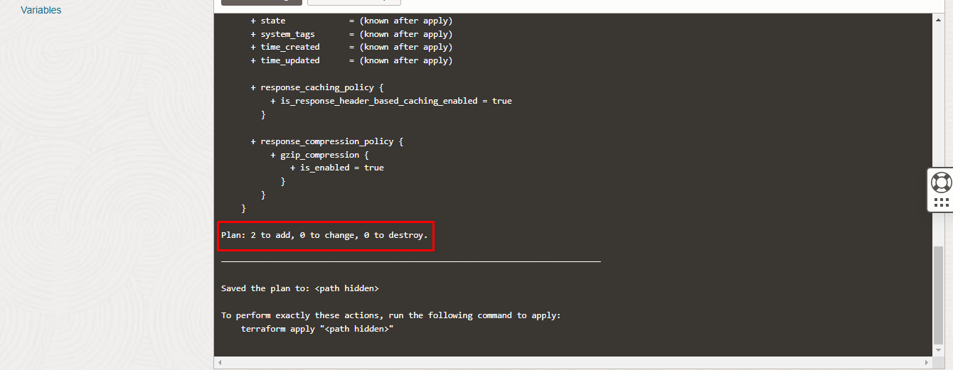

Apply the Job

Once the “plan” is success, now click “Apply”

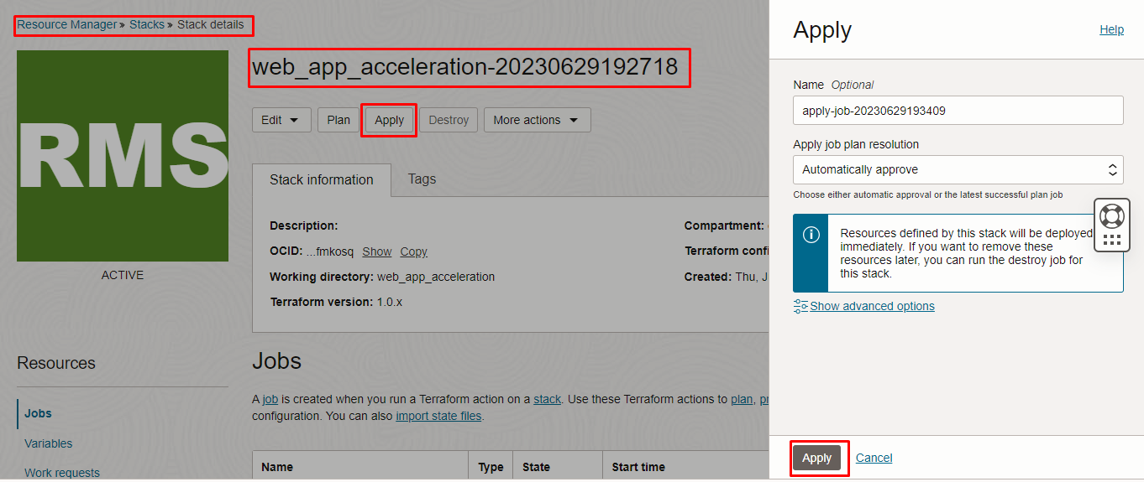
Verify the Apply is successful.

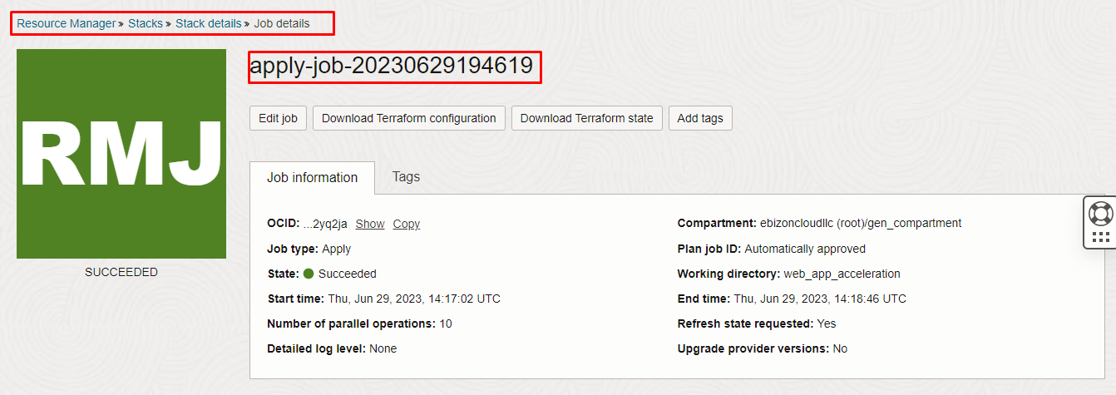

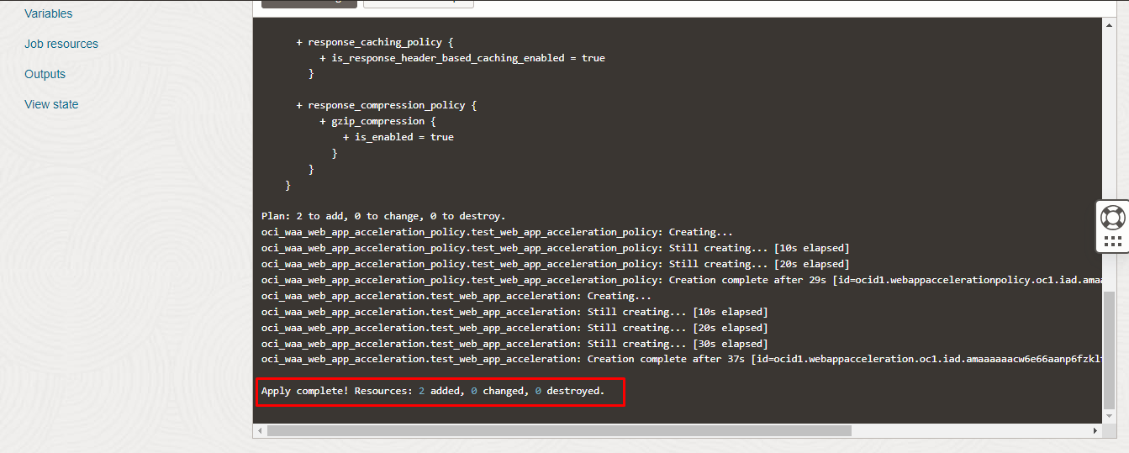

Verify in the Console

Go to OCI Console Networking Web Application Acceleration

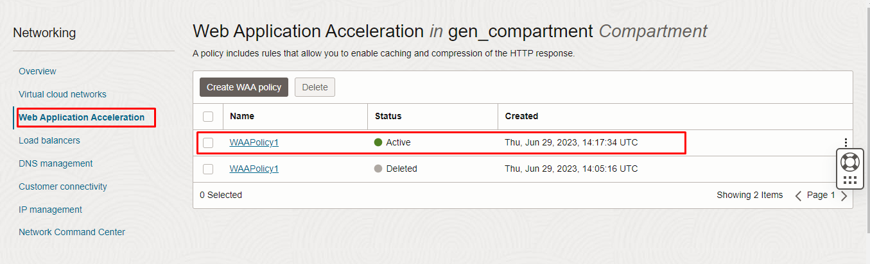
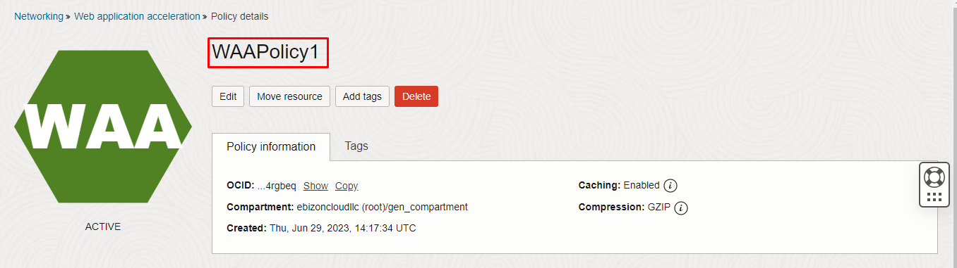
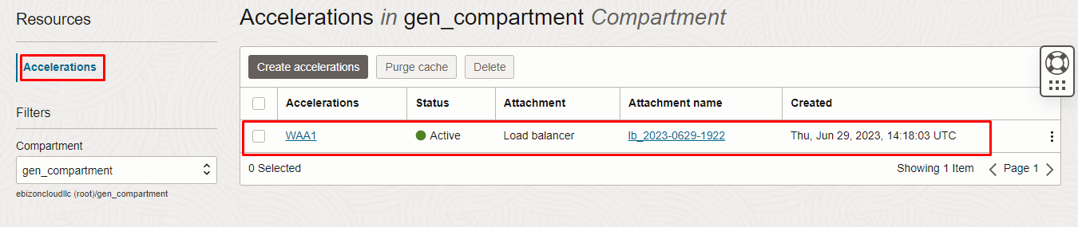

Destroy the stack

Create a destroy job in Resource Manager to release resources associated with a stack and clean up the tenancy. Once destroyed data cannot be recovered from resources.

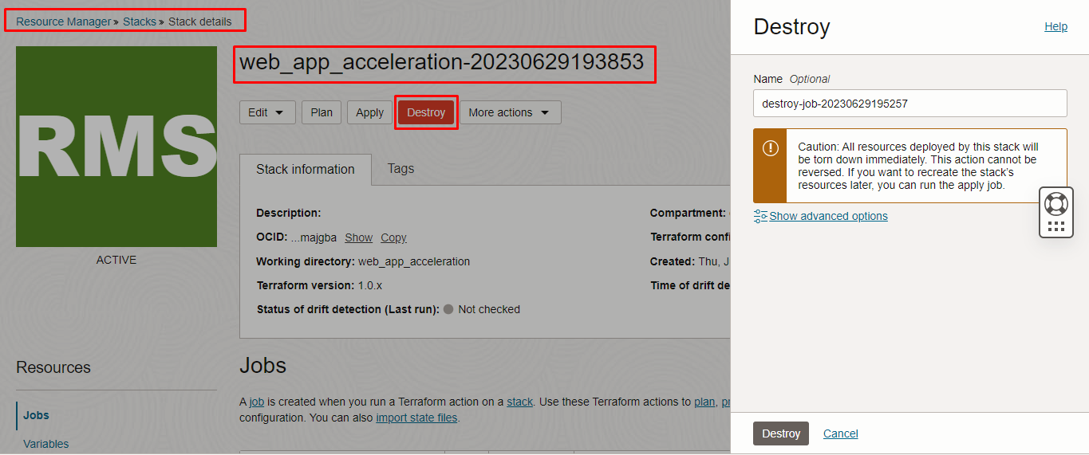

###############END###############

